Java assignment

1)CHECK WHETHER NUMBER IS PALINDROME OR NOT

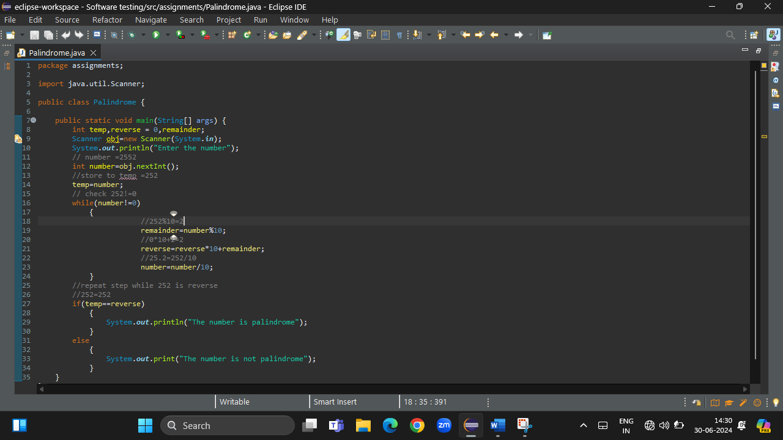

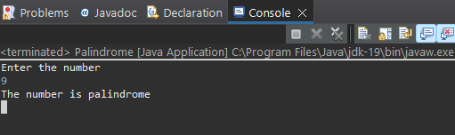

2)FIND THE FACTORIAL OF ENTERED NUMBER

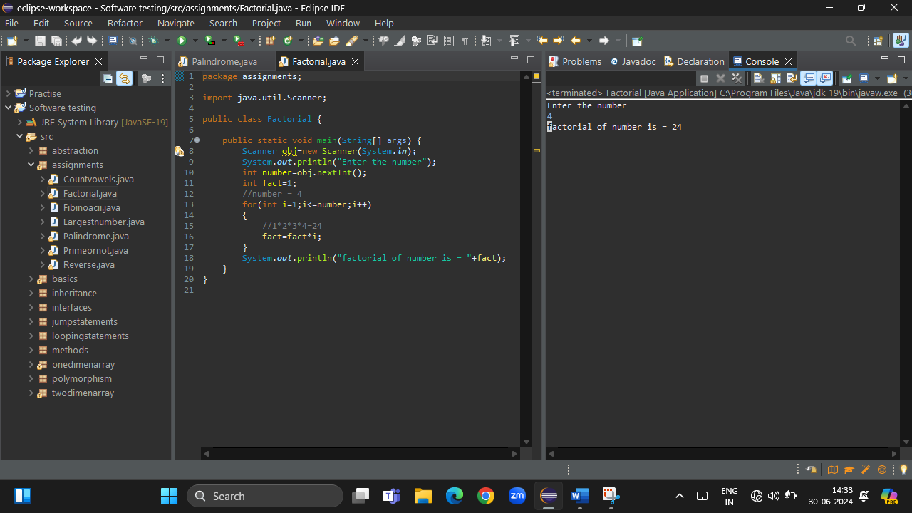

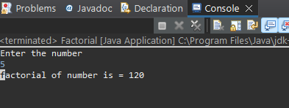

3)REVERSE OF A STRING

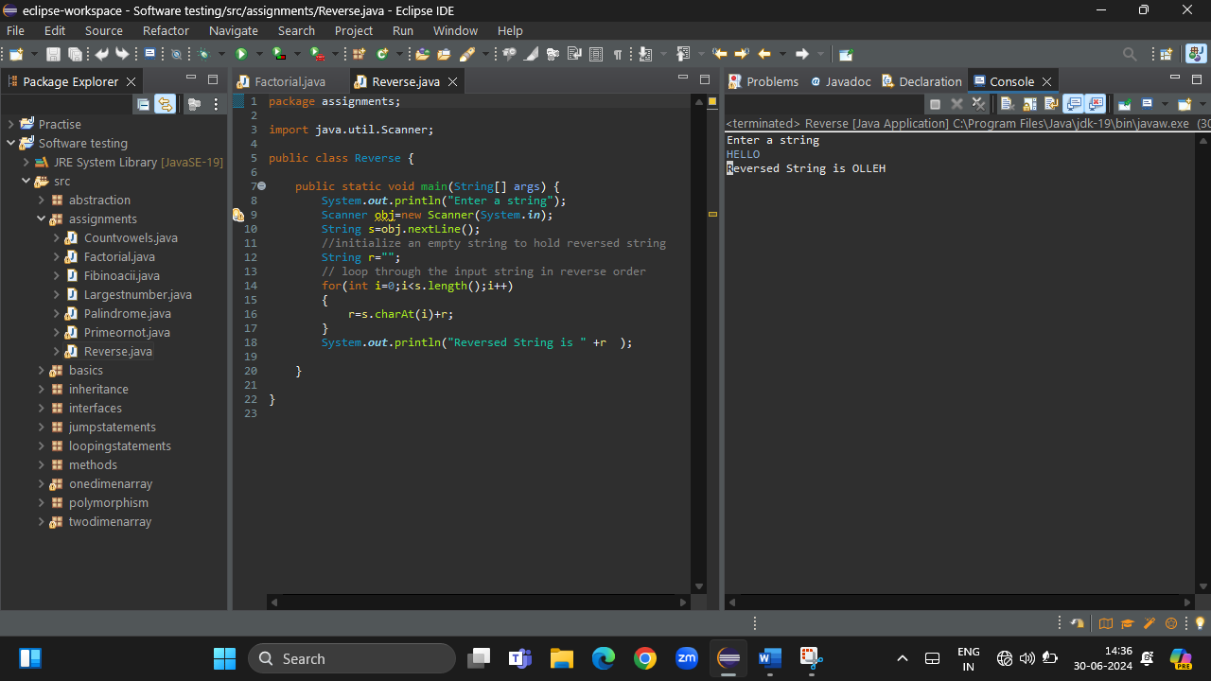

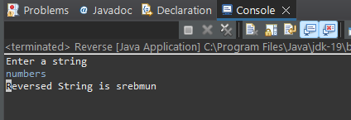

4)COUNT THE NUMBER OF VOWELS IN A STRING

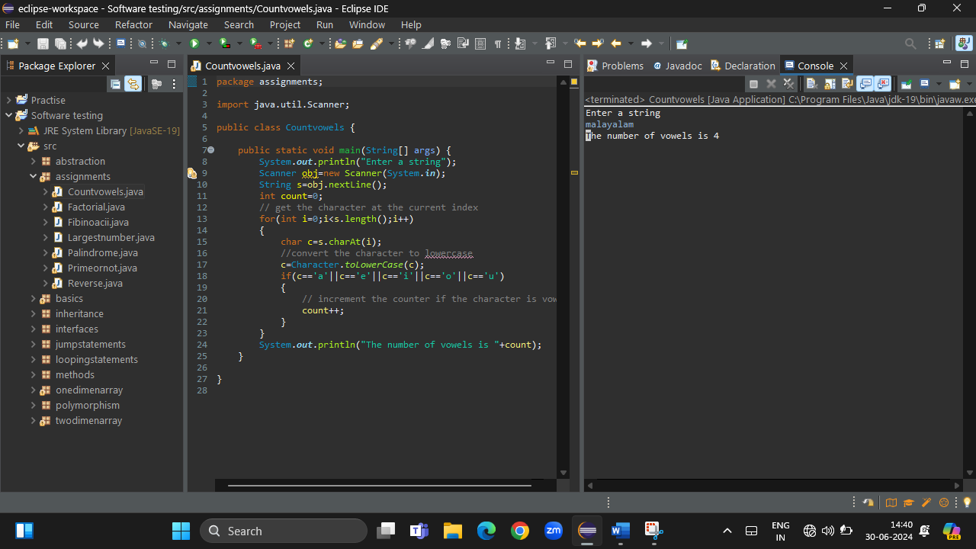

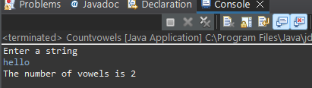

5)PRINT FIBINOACCI SERIES

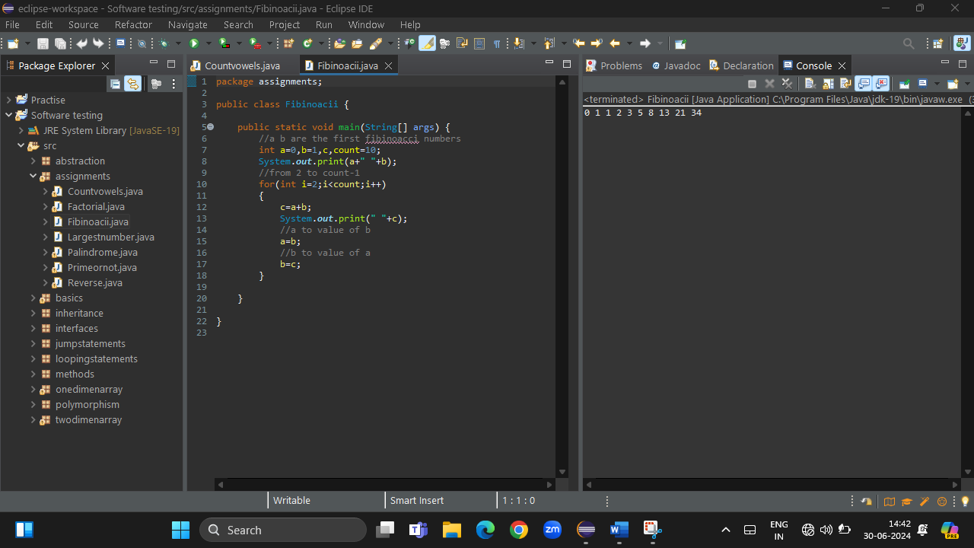

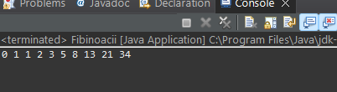

6)CHECK WHETHER THE NUMBER PRIME OR NOT

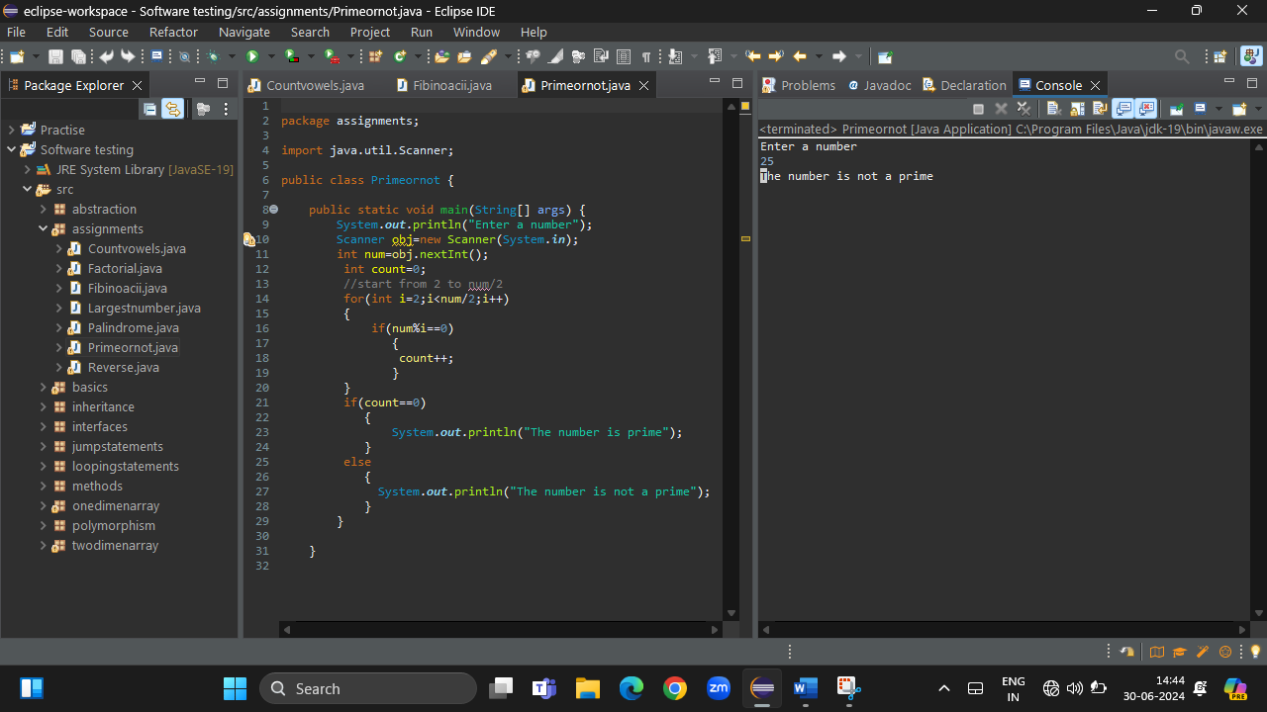

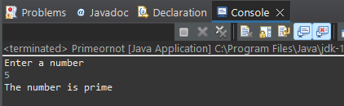

7)FIND THE LARGEST NUMBER IN AN ARRAY

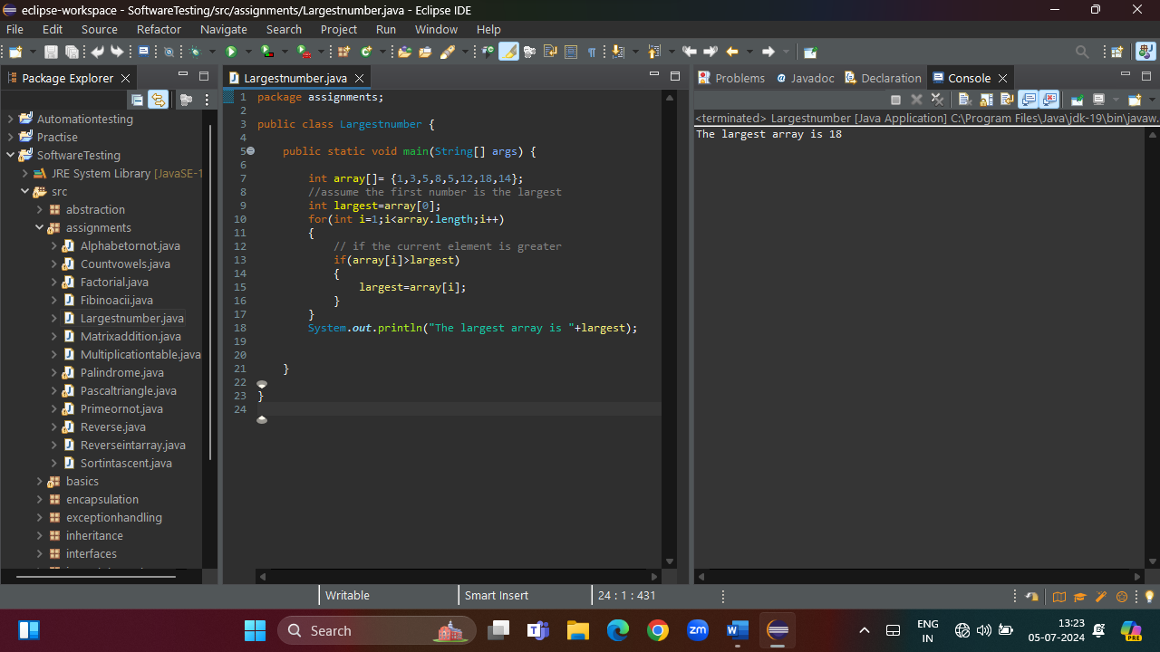

8)REVERSE AN INTEGER ARRAY

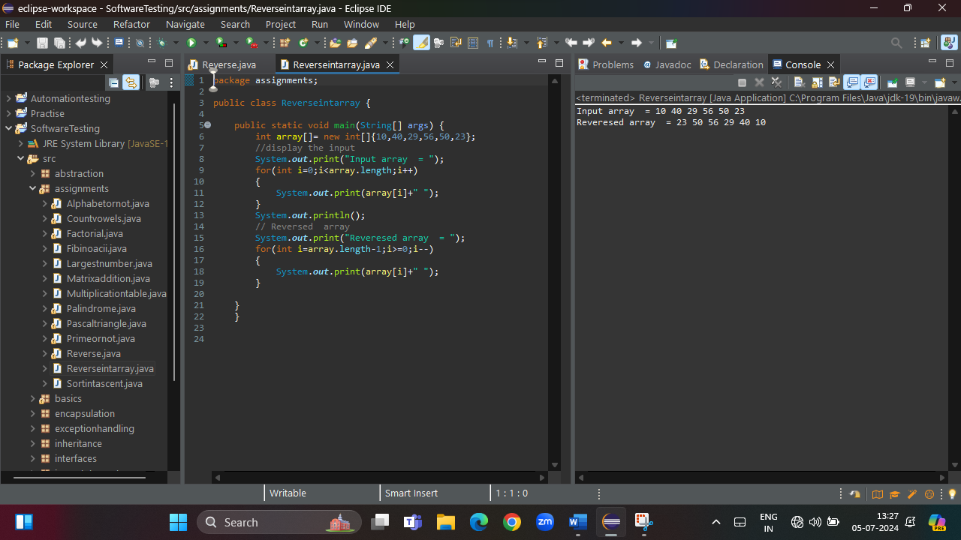

9)SORT ARRAY IN ASCENDING ORDER

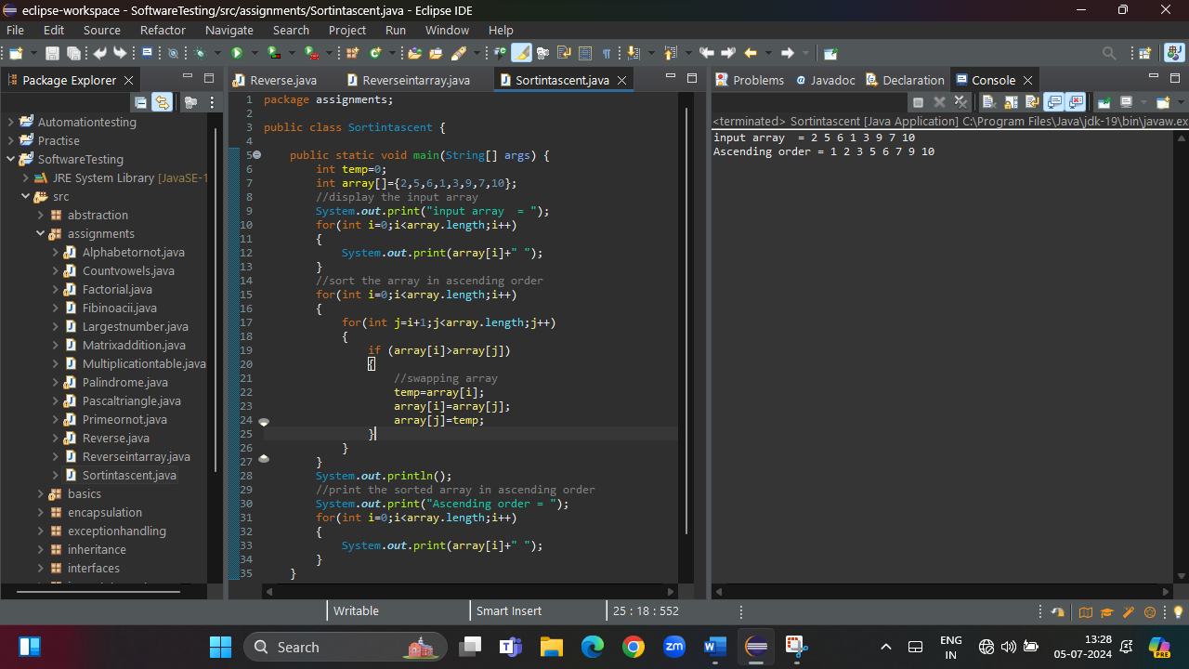

10)3\*3 MATRIX ADDITION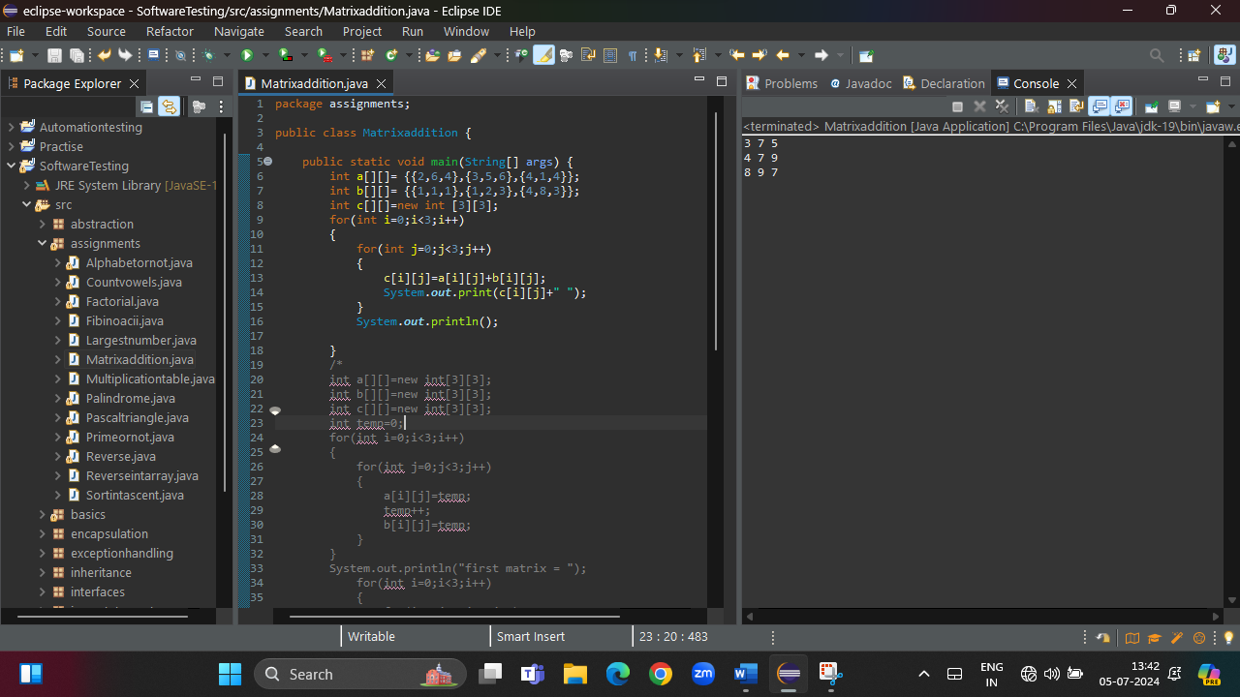

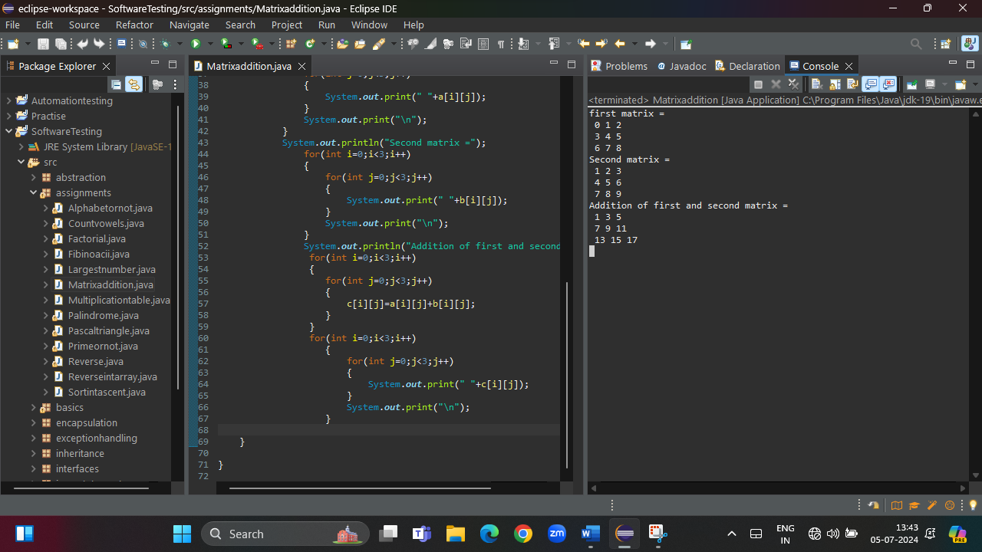

11)PRINT PASCAL TRIANGLE

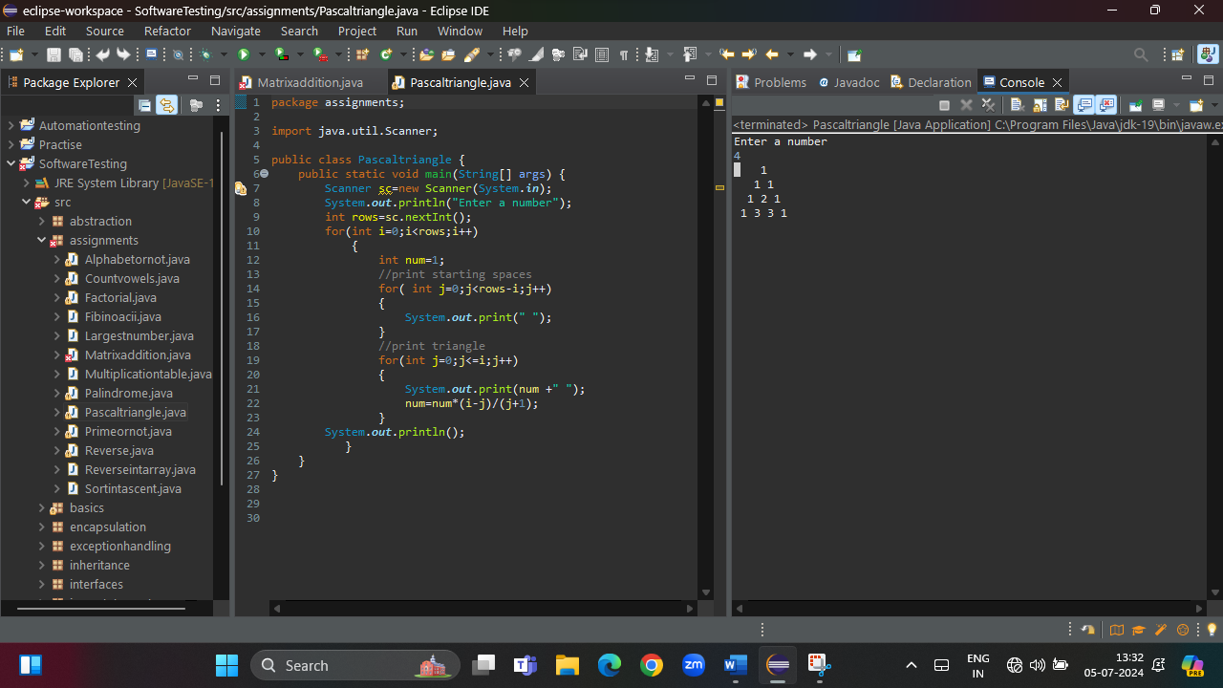

12)MULTIPLICATION TABLE WITH ENTERED A NUMBER FROM 1 TO ANY LIMIT

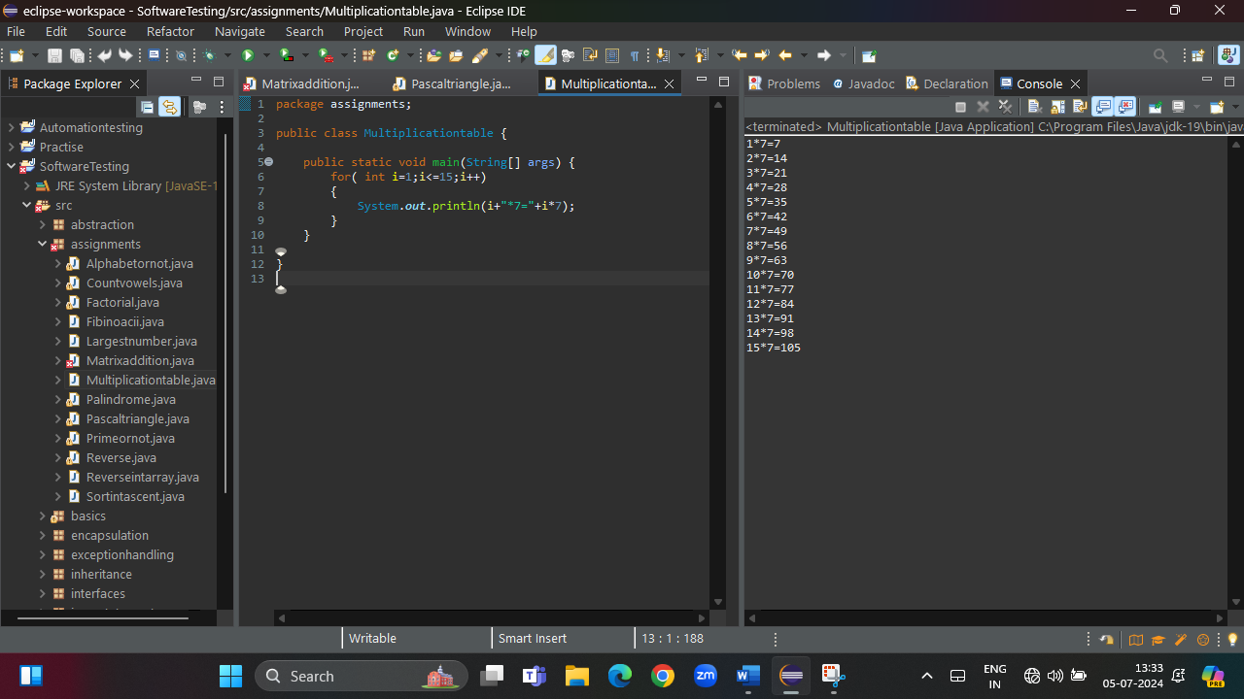

13)CHECK WHETHER THE ENTERED VALUE IS ALPHABET OR NOT

